# 

**Numerical Simulation and Optimization of Alternate Ventilation Systems inside an Aircraft Cabin**

***Prithvi Ramesh***

Table of Contents

1

**Chapter 1: Abstract 4**

**Chapter 2: Background 5**

**2.1. Aircraft Ventilation: 5**

**2.2. Human thermal comfort 5**

**2.2.1. Predicted Mean Vote 8**

**2.2.2. Predicted Percentage Dissatisfied 9**

**2.3. Heat Removal Efficiency 9**

**2.4. Quality of Air 10**

**Chapter 3: Computational Setup: 12**

**3.1. Governing Equations 14**

**3.2. Optimization Setup 16**

**Chapter 4: Grid Independence: 18**

**Chapter 5: Results and Discussion 21**

**Chapter 6: Bibliography 25**

**Table of Figures**

**Figure 1: Human Thermal Comfort Parameters 6**

**Figure 2: Ventilation Scenarios. (a)-Mixed Ventilation. (b)-Cabin Displacement Ventilation. (c)-Ceiling-Based Cabin Displacement Ventilation 11**

**Figure 3: Dornier-728 Cabin Model 12**

**Figure 4: Human Dummy along with cabin seat 12**

**Figure 5: Dimensions 13**

**Figure 10: Data for Relative Humidity= 14% and Clothing Factor =0.73. (a)-Predicted Mean Vote. (b)-Predicted Percentage Dissatisfied. 23**

**Figure 11: Data for Relative Humidity= 14% and Clothing Factor =0.76. (a)-Predicted Mean Vote. (b)-Predicted Percentage Dissatisfied.** Error! Bookmark not defined.

**Figure 12: Data for Relative Humidity= 17% and Clothing Factor =0.73. (a)-Predicted Mean Vote. (b)-Predicted Percentage Dissatisfied** Error! Bookmark not defined.

**Figure 13: Data for Relative Humidity= 17% and Clothing Factor =0.73. (a)-Predicted Mean Vote. (b)-Predicted Percentage Dissatisfied** Error! Bookmark not defined.

**Figure 14: Quality of air- Age of Air 24**

# Abstract

Traditional aircraft ventilation systems have lately been struggling to meet the demands of the modern aircrafts which are more densely populated and have higher heat loads. Alternate ventilation systems for aircraft cabin ventilation are being explored which can improve cabin ventilation for increased heat loads. The German Aerospace Center (DLR) conducted experiments on a novel ventilation concept in which supply air was fed from both the ceiling and the floor on a Dornier 728 aircraft cabin- this type of ventilation was termed – Ceiling-based Cabin Displacement Ventilation (CCDV). In this study, an optimization scheme is used to determine the best possible combination of the supply flow rates from the ceiling and from the floor for the best ventilation performance assuming steady state uniform environment for the cabin. A geometric model was created for the Dornier 728 asymmetrical cabin and human dummies were added to the seats, a computational fluid dynamics (CFD) analysis of different ventilations scenarios was conducted. The environmental conditions was taken as ideal for an aircraft cabin like low humidity, low pressure, warm clothes and no physical activity. The various combinations were compared on basis of Thermal Comfort of passengers, Quality of Air in the cabin, Uniformity of cabin temperature and the Efficiency of Heat Removal of the ventilation system.

# Background

## Aircraft Ventilation:

The standard form of ventilation is the Mixed Ventilation (MV) where cooled air is supplied at high momentum [1] [2] through the lateral ceiling outlets and lateral MV outlets and exits the cabin through dado outlets on the cabin floor [1]. Although their energy consumption has been reduced considerably- they suffer from drawbacks like uncomfortable draft and noise [1], they are also ineffective in controlling the spread of a pathogen [1]. The thermal comfort of MV is also reduced since air is supplied at high momentum which results in higher velocities. A cabin displacement ventilation (CDV) supplies cooled air at very low velocity at the floor of the cabin, underneath the passenger’s seat. The air then rises due to heat given off by heat sources like passengers, IFE systems and lamps. The warm air is exhausted through laterally positioned ceiling inlets which were hitherto used for air supply in the MV systems. The CDV and MV were thoroughly compared and contracted by Zhang and Chen [3] and Yin and Zhang [4] in terms of temperature uniformity, carbon dioxide concentrations and air velocities using CFD for a Boeing 767 model. The German Aerospace Center (DLR) [1] explored a further new concept of ventilation where supply air at very low momentum was supplied from displacement ventilation (DV) outlets vertically from ceiling and from the floor outlets- this creates a “lake of fresh air” which teaks away heat from the passengers and raises due to buoyancy and exists from the lateral MV outlets operated in reverse. This arrangement is called Ceiling based Cabin Displacement Ventilation- CCDV at ground level conditions using human dummies in a full-scale mockup of the Dornier 728 narrow body aircraft at Gottingen. A total of four hybrid combinations of CCDV and CDV were explored and their performance was compared to a MV system. The present study aims to recreate the cabin layout of the study conducted by DLR and optimize the CDV and CCDV combination for best ventilation performance and passenger thermal comfort.

## Passenger Thermal Comfort

Human thermal comfort is the absence of discomfort due the feeling of excessive heat or cold [5]. The perception of discomfort or comfort in different thermal environments depends on many personal factors like clothing level, metabolic rate, physical activity, sex, age and state of mind. Since the sensation is psychological in form and varies from person to person- models used to predict thermal comfort in given environmental and personal conditions are based on extensive surveys [6] [7] . According to ASHRAE 55 recommendations [8] ensuring thermal comfort means to maintain the inner body temperature between 36-38 degrees Celsius. This is achieved when heat produced by body is lost and no heat is stored or excess heat loss than produced doesn’t take place. There should be no unbalance between heat produced and heat lost.

### PMV/PPD Model

The Predicted Mean Vote/ Predicted Percentage Dissatisfied model was developed by P.O.Fanger [7]. The model predicts the thermal comfort in a given environment using heat balance equations and thermal comfort surveys. The elements of the physical environment considered are the air temperature, mean radiant temperature, relative humidity, air speed, clothing level and metabolic rate.

Figure 1: Human Thermal Comfort Parameters

Metabolic Rate: The human body produces mechanical work (W) along with heat (Q), and the total energy produced is called metabolic rate (M=W+Q). It is expressed in Met (1 Met = 58.1 W/m2). Higher activity = Higher Metabolic rate [9]. The physical conditions and the associated metabolic activities are summarized below:

|  |  |
| --- | --- |
| Sitting | 1 Met |
| Sleeping | 0.8 Met |
| Sedentary activity | 1.2 Met |
| Standing or light activity | 1.6 Met |
| Medium activity | 2 Met |
| Driving | 1 to 2 Met |
| Cooking | 2 Met |
| Cleaning | 3 Met |
| Playing | 4 Met |
| Hiking | 6 to 7 Met |
| Running | 3 to 8 Met |

Table 1: Metabolic Rates

Mean Radiant Temperature is the uniform temperature of an imaginary enclosure, in which the radiant heat transfer from the human body is equal to radiant heat transfer in the actual non-uniform enclosure. It is the function of the position at which it is measured. It changes with finish of the reflective surface [9].

Air temperature has a direct impact on thermal comfort. Mean radiant temperature takes into the consideration the air velocity and temperature & globe temperature. The globe temperature is the temperature of air only, but it takes into account the effects due to radiation (Globe Thermometer).

Relative humidity: A higher quality of moisture in the surroundings can hinder the loss of heat from perspiration, which causes thermal discomfort.

Clothing level: Thermal Resistance arises through clothing insulation and the metric used for it is “clo”- 1 clo = 0.155 m2K/W (summer = 0.5 clo, winter = 1 clo, naked person = 0 clo) [9].

Air Speed: Moving air aids forced convection of the moisture secreted by humans when they perspire.

The PMV is an index which predicts the average climate assessment value of a large group of people. The PPD Index provides a quantitative prediction of the number of people that will be dissatisfied.

### Predicted Mean Vote

The PMV is a non-dimensional quality which predicts the average vote of a large group of people in a 7-point scale:

|  |  |
| --- | --- |
| Predicted Mean Vote | Thermal feeling |
| -3 | Very Cold |
| -2 | Cool |
| -1 | Slightly Cool |
| 0 | Neutral (Most Comfortable) |
| 1 | Slightly Warm |
| 2 | Warm |
| 3 | Very Hot |

Table 2: PMV 7-point scales

An empirical equation is used to calculate the PMV for a given set of environmental conditions:

|  |  |
| --- | --- |
| ***PMV = [0.303*exp(-0.036*M) + 0.028] * {(M-W) – 3.05*10^ (-8) *fcl*[(Tcl + 273.15) - (Tr + 273.15)] – fcl*hconv*(Tcl - Ta) – 3.05*[5.733 - 0.007*(M-W) – 0.001*pw] - 0.42*[(M-W) – 58.15] – 0.0173*M*(5.867 - 0.001*pw) – 0.0014*M*(34-Ta)}*** | (1) |

Where,

M: Metabolic rate (W/m2)

W: Effective Mechanical power (W/m2)

fcl: Clothing surface area factor

Tcl: Clothing surface temperature (oC)

Ta: Air temperature (oC)

Tr: Mean radiant temperature (oC)

pw: Water vapor partial pressure (Pa)

hconv: Convective heat transfer coefficient (W/ (m2.K))

And,

Tcl = 35.7 – 0.028 *(M-W) – Icl * {3.96*10^ (-8) * fcl*[(Tcl+273.15) ^4 -(Tr-273.15) ^4] + fcl*hconv*(Tcl-Ta)}

hconv= {2.38*|Tcl-Ta|^0.25 for 2.38*|Tcl-Ta|^0.25>12.1*Var}

= {12.1*Var for 2.38*|Tcl-Ta|^0.25<12.1*Var}

fcl = {1 + 1.290*Icl for Icl<=0.078 m2.K/W}

= {1.05 + 0.645*Icl for Icl>0.078 m2.K/W}

Var: relative air velocity (m/s)

Icl: clothing insulation (m2.K/W)

### Predicted Percentage Dissatisfied

Based on surveys conducted on a large group of population a subjective metric of thermal satisfaction was also developed which predicts the percentage of people who would not feel thermal satisfaction- it is based on a known PMV condition,

*PPD = 100 – 0.95exp (-0.03353*PMV^ (4) – 0.2179*PMV^ (2))*

The lower the PPD – the better are the thermal conditions inside the aircraft cabin.

Passengers thermal Comfort is a common issue with modern aircraft cabins [10]. The parameters affecting thermal comfort are air temperature, air velocity, relative humidity, black globe temperature, human metabolic rate, clothing and gender- the last two factors are personal and the remaining are external [9].The aircraft cabin is densely populated and narrow, so we have to consider these factors mainly for longer duration flights.

The average air temperature lies between 21-24 degrees Celsius, still in most of flights besides temperature regulation; the thermal discomfort is felt appreciably. Therefore, many methods are continuous being investigated and researched for getting better Environmental Control System (ECS), further the top airline manufacturer like Boeing and Airbus are considering the passenger thermal comfort as a competition.

Modern aircraft cabin has a higher heat load than they had before- the increased passenger capacity, in-flight entertainment, cabin lights all contribute to the increased load. Alternate ventilation concepts with increased efficiency are increasingly being explored in recent literatures [1]. While there are many ongoing efforts to introduce more efficient components like heat exchangers and compressors of the refrigeration system, the purpose of alternate ventilation is to reduce the energy consumption by ECS, reduce cabin weight and improve passenger thermal comfort [1] [5].

## Heat Removal Efficiency

The Heat Removal Efficiency (HRE) [11] is taken as the ratio of the difference of the average air temperature in the outlet and the average inlet air temperature to the difference in the average temperature of the whole cabin and the inlet air temperature. Higher the value of the HRE the lower would be the energy consumption by the Environmental Control System (ECS) to maintain a certain cabin temperature.

|  |  |
| --- | --- |
|  | (2) |

Where:

## Quality of Air

Air quality of “freshness” of air in the cabin is vital for passenger’s comfort- especially for long-haul flights. Aircraft cabins have been notorious for high CO2 concentrations and bad air quality [1] [10]. Age of Air (AoA) measures the quality of air as the amount of time the air lingers inside the control volume with the entry or inlet considered to be zero seconds. The higher AoA- the less would be the quality of air. A separate transport equation is used for the age of air [5].

|  |  |
| --- | --- |
|  | (3) |

Where,

The AoA is added as a volumetric variable, and its total source term is taken as 1 s- which implies that its increment is in 1 s.

|  |
| --- |
| (a)    (b)    (c) |

Figure 2: Ventilation Scenarios. (a)-Mixed Ventilation. (b)-Cabin Displacement Ventilation. (c)-Ceiling-Based Cabin Displacement Ventilation

# Computational Setup:

A model of the Dornier 728 narrow-body aircraft is was used in the study. Ten seats with human dummies were arranged in a “2-3” single aisle configuration bringing the number of rows considered up to 2. Data published on the physical aircraft model was used for calculating the dimensions. The surface areas for the supply outlets were calculated taking into consideration the heat load of the actual aircraft which has 14 rows of seats while the model used in this study has only 2 rows. The outlet from the ceiling (DV outlets) has a width of 0.69m, they have an effective area of 1.12253 m2. The floor-based outlets have a surface area of 0.0852 m2 per passenger [inert citation] and are present underneath each seat. The lateral MV outlets and lateral ceiling outlets were dimensioned using cabin design layouts [12].

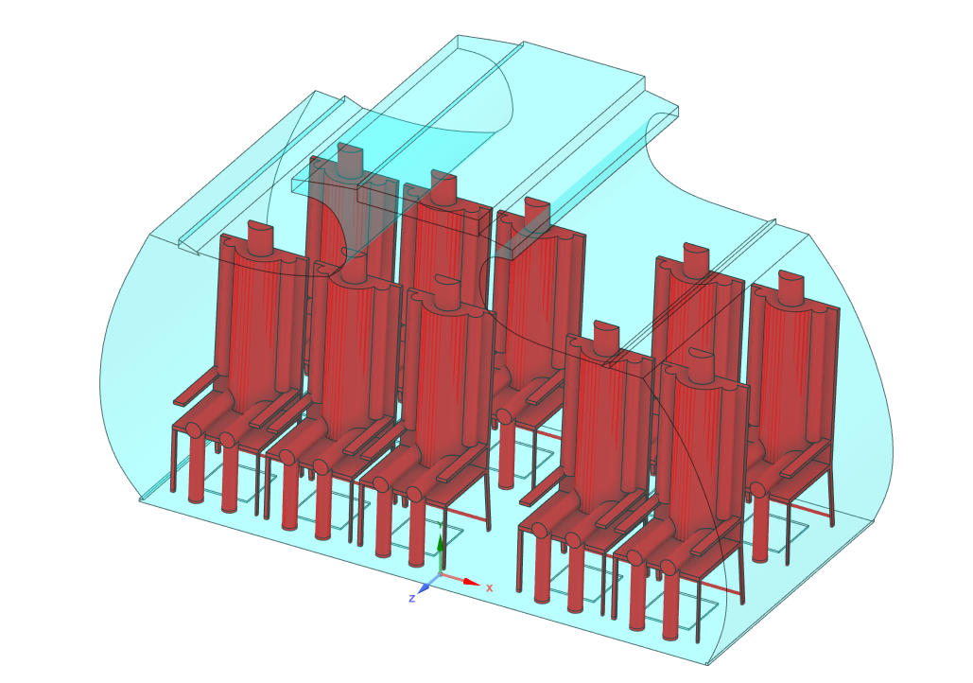

Figure 3: Dornier-728 Cabin Model

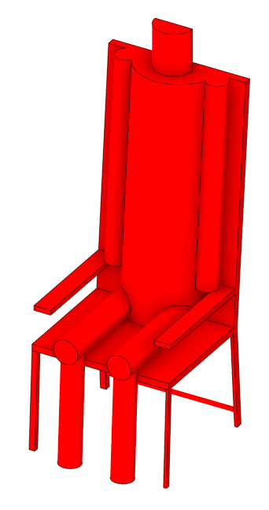

Figure 4: Human Dummy along with cabin seat

|  |
| --- |
| (a)    (b) |

Figure 5: Dimensions

Due to the low relative humidity present in aircrafts – the study has considered two values of Relative humidity – 14% and 17% [13].

The clothing factor has been taken as 0.76 for a man and 0.73 for a woman based on the following articles of clothing common to both[insert]:

1. Standard Office Chair
2. Underwear
3. Boots
4. Long-sleeve dress shirt
5. Thick Trousers
6. Calf length socks

The passenger dummies were given a metabolic rate of 1 *Met* 58 W/m2, due to which their skin temperature was taken as 34 oC which was calculated trough the relation [14]:

|  |  |
| --- | --- |
|  | (4) |

where,

M: Metabolic rate (W/m2)

W: Work activity (W/m2) which is taken as zero.

Heat is transferred from the human body to the surrounding cabin air predominantly through natural convection due to the low air momentum. Oguro et al[15] carried out extensive experimental analysis of convective heat transfer coefficients for clothed and naked human mannequins and for individual body parts. The convective heat transfer coefficients were found to vary approximately linearly with the external velocity, in addition the coefficients were considerably higher for clothed persons for higher velocities. Due to the low velocities encountered in aircraft cabins the convective heat transfer has been taken as 5 W/m2/K for whole clothes sitting mannequin. The air supply rate of the Do 728 aircraft’s ECS cabin is 600 l/s [1], the present study however includes a model of length 1.63 m as opposed to the 16.9m length of the full aircraft cabin- in proportion the volumetric air supply is taken as 57.8598 l/s, this is distributed between the supply from ceiling and from the floor. Both supplies are given with 21 oC and the Age of Air reference is zero seconds. Buoyancy (Ref Temp 21 oC) is enabled for the computational domain along with gravity. The reference pressure is taken as 0.786 *atm*corresponding to flight level 6500 feet [1]. The supplies from both floor and ceiling are given medium 5% turbulence intensity.

Ansys CFX was used as the platform for the simulations; the buoyancy model with reference temperature 21 oC was enables along with gravity. The steady state simulation was run for 400 iterations with the RMS residual convergence criteria set at 1E-04.

## Governing Equations

The turbulence was modeled using Shear Stress Transport developed by Menter (1994) [16]. The Reynolds Averaged- Navier-Stokes (RANS) equations employ the Reynolds approximation to model turbulent behavior- the velocity components are broken into fluctuating and mean components- the fluctuating components are combined to form an extra stress term called “Reynolds stress”. In order to close the N-S equations different approaches are used to model the Reynolds stress: among them- , and RSM (Reynolds Stress Transport). Zhang et al [17] compared the performance of the three models for indoor applications and concluded that the model showed the best agreement with experimental data and is delivers superior performance over the other two for predicting air velocities and air temperature inside a confined room [17]. The Direct Numerical Simulation (DNS) approach does not use an approximation and delivers the most accurate result of the N-S equations, however in order to stabilize the equations the grid has to be extremely fine. The same is true for the Large Eddy Simulation which breaks down the turbulent behavior into large and small eddies. Due to the unavailability of the computational power required for LES and DNS- the RANS is used.

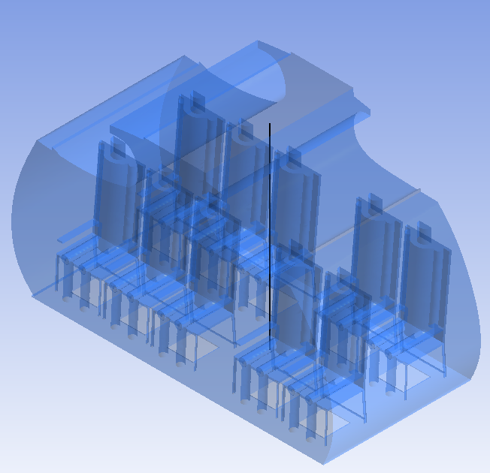

Figure 6: Vertical line used for Data sampling for Grid Independence study

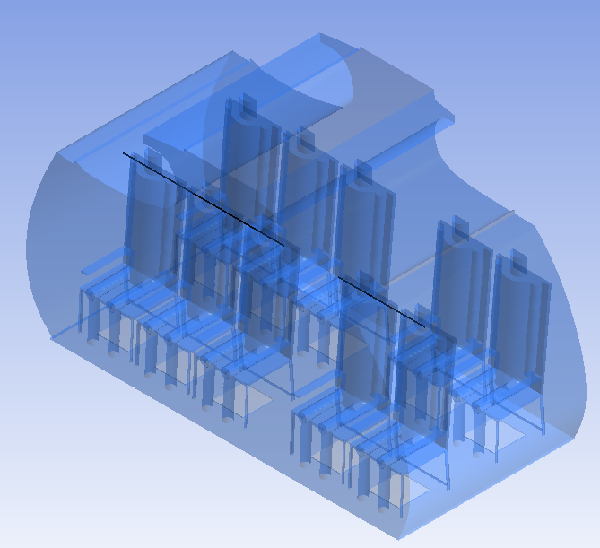

Figure 7: Two Horizontal lines for Data Sampling for Optimization study

## Optimization Setup

A design of experiment (DOE) analysis determines the sensitivity of each controllable input parameter or factors- this methodology is often termed fractional factorial method. In order to do so, Ansys DesignXplorer uses a variety of schemes to adequately include the interest area- in the present study a set of Design Points (DPs) were created using the default Central Composite Design (CCD). The “screening” method was used to generate the discrete parameter set, DesignXplorer also allows continuous values (or manufacturable values) through schemes like MOGA, Adaptive Multi Objective and Adaptive Single- Objective. [18] [19]

Goal-Driven Optimization (GDO) was conducted for the set of 20 DPs with consisted of only one input parameter – due to the relatively smaller size of the parameter set a Direct Optimization method was preferred over a Response Surface Optimization.

Figure (7) illustrates the methodology of data sampling used for the optimization, data of velocity, temperature and Age of Air (also solved through transport equation) has been collected along a straight-line segment near the head region of the passengers for both cabin sides. Due to the asymmetric cabin – the comfort indices were averaged using two “weights” – 2 and 3. Therefore the comfort indices used for the full cabin was calculated as:

|  |  |
| --- | --- |
|  | (5) |

Where,

The optimization scheme is expressed mathematically as:

Minimize/Maximize (Objective Function(s))

Subject to: (Constraints)

 (Bounds),

Here are the decision variables

**Objective Function(s):** The goal of the optimization was to decrease the Age of Air (improved ventilation performance) and to improve the thermal comfort of the passengers- the effect on the indices was to decrease the PPD, ASHRAE recommends the optimum range of PMV between -0.5 and 0.5.

**Design Variable(s):** Percentage of the total air supply that is fed into the cabin from the ceiling- the deficient is supplied through the floor. A total of 20 samples were used with the percentage of supply from the ceiling increased by 5% from 2.5%, 7.5%, 12.5%....97.5%.

**Decision variable(s):** PPD and PMV are the two thermal comfort indices used in the study, since they need an input of velocity and temperature- both of them are computed using Navier-Stokes equations and Energy Transport equation respectively for each point on the two-line segments. A length averaged value for the pair was done for each line segments which was subsequently used to compute the length averaged PDD and PMV values for the two seats side and the three seats side. Age of Air was similarly computed through the transport equation (Eqn. 3).

**Constraints:** The ceiling supply which is the sole input parameter was constrained between 0 and 100.

# Grid Independence:

Ansys mesher was used for generating the grid; the element size used is of the order 0.004 meters. Facing sizing was used to increase the concentration of grid points in the cabin ceiling and floor outlets.

|  |  |
| --- | --- |
| Mesh Metric | Value |
| Minimum Element Quality | 5e-02 |
| Maximum Element Quality | 0.99996 |
| Average | 0.6995 |
| Standard Deviation | 0.1382 |

Table 3: Mesh Quality Data

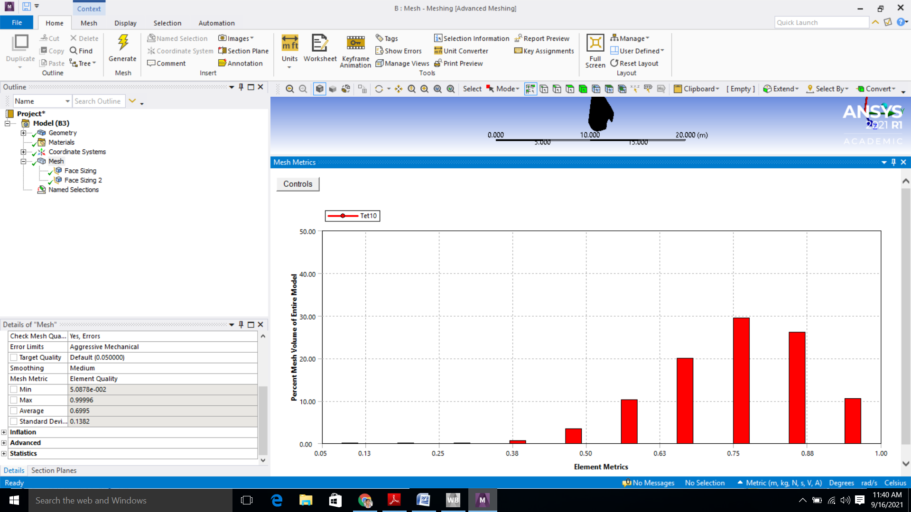

Figure 8: Histogram of mesh quality distribution

Four variations of the mesh were used to affirm the independence of the study on the number of elements in the gird which are summarized below:

|  |  |  |
| --- | --- | --- |
| Mesh Number | Element Size(m) | Number of Nodes |
| 1 | 4E-02 | 278139 |
| 2 | 2.5E-02 | 393649 |
| 3 | 2.1E-02 | 485955 |
| 4 | 2.03E-02 | 507298 |

Table 4: Meshes considered for Grid Independence

The average value of the Age of Air (AoA) along the vertical line in Figure (8) was used as the metric for the grid independence. The results of the grid independence study are shown in Table (5), the “Mesh No.2” was used for the optimization study.

|  |  |  |
| --- | --- | --- |
| Mesh No. | Number of Elements | Age of Air |
| 1 | 278139 | 81.76 |
| 2 | 393649 | 103.28 |
| 3 | 485955 | 102.70 |
| 4 | 507298 | 100.39 |

Table 5: Grid Independence Result

|  |
| --- |
| C:\Users\user\Desktop\Rac-Ansys-Final-of-All\Images\mesh-1.png  (a)  C:\Users\user\Desktop\Rac-Ansys-Final-of-All\Images\mesh-2.png  (b)  C:\Users\user\Desktop\Rac-Ansys-Final-of-All\Images\mesh-3.png  (c) |

Figure 9

# Results

By analyzing the optimization results- six supply percentage values were identified as the most promising in terms of thermal comfort and quality of air- 2.5%, 7.5%, 12.5%, 17.5%, 22.5% and 37.5%. These percentages were further analyzed for uniformity of temperature and the heat removal efficiency: -

|  |  |  |  |
| --- | --- | --- | --- |
| Ceiling Supply Percentage | Heat Removal Efficiency | Cabin Average Temperature(k) | Variance of Cabin Temperature(k) |
| 2.5% | 1.580 | 296.258 | 1.602 |
| 7.5% | 1.064 | 296.295 | 1.576 |
| 12.5% | 0.952 | 296.329 | 1.538 |
| 17.5% | 0.893 | 296.354 | 1.499 |
| 22.5% | 0.864 | 296.368 | 1.467 |
| 37.5% | 0.817 | 296.389 | 1.400 |

Table 6: Results for the Optimized cases- Heat Removal Efficiency, Average Temperature and Uniformity of cabin temperature

|  |
| --- |
| ***(a) (b)***    ***(c) (d)*** |

Figure 10: [(a)-(b)] Data for Relative Humidity= 14%, Clothing Factor =0.73. [(c)-(d)] Data for Relative Humidity -14%, Clothing Factor=0.76

|  |
| --- |
|   ***(a) (b)***    ***(c) (d)*** |

Figure

Figure

Figure 11: [(a)-(b)] Data for Relative Humidity= 17%, Clothing Factor =0.73. [(c)-(d)] Data for Relative Humidity -17%, Clothing Factor=0.76

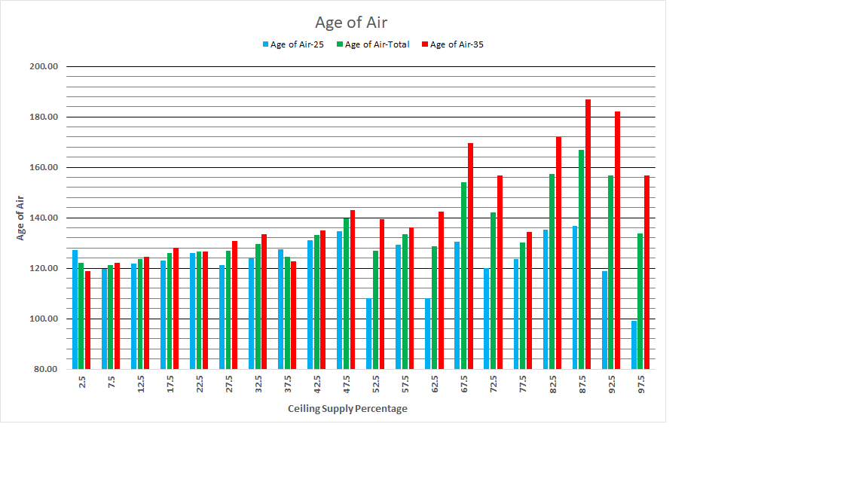

Figure 8: Quality of air- Age of Air

# Conclusions

The 2-seats side had a higher PPD than the 3-seats side. This is due to the proximity of the passengers in the 3-seats side which results in a warmer surrounding and lower air velocities. The proximity of neighbors in the 3-seats side also results in a less negative PMV, the variations in the values of the PPD in the 3-seats side is also much lower. The values of PPD are comparatively lower for the below 50% ceiling supply- the reason is that the air is supplied at lower momentum and increase the comfort level of passengers. It is also desirable to reduce the risk of draft by supplying air at low momentum [7]. The quality of air in the cabin is enhanced when a higher percentage of the supply is supplied through the floor, the reason behind this is that air supplied thought the floor is heated through convection from heat sources and rises through the head region of the passengers, however for air supplied through the ceiling a circulating convection system is setup. This can also be advantageous in containing the spread of air-borne pathogens. Amongst the six selected values- the heat removal efficiency was the highest for the 2.5% ceiling supply, however supplying most of the air through the cabin floor has certain operational difficulties [1]. The 37.5% ceiling supply has the most uniform cabin temperature distribution (lowest variance). The trends suggest that when air is supplied predominately from the ceiling- the heat removal efficiency is reduced but due to the resulting convection circulation- the temperatures in the cabin are more uniform. The load on the ECS is also increased since the exiting air is warmer.

# Bibliography

|  |  |
| --- | --- |
| [1] | J. Bosbach, S. Lange, T. Dehne, G. Lauenroth, F. Hesselbach and M. Allzeit, "Alternative ventilation concepts for aircraft cabins," CEAS Aeronautical Journal, vol. 4, p. 301–313, 2013. |
| [2] | J. Maier, C. Marggraf-Micheel, T. Dehne and J. Bosbach, "Thermal comfort of different displacement ventilation systems in an aircraft passenger cabin," Building and Environment, vol. 111, p. 256–264, 2017. |
| [3] | T. Zhang and Q. Y. Chen, "Novel air distribution systems for commercial aircraft cabins," Building and Environment, vol. 42, p. 1675–1684, 2007. |
| [4] | S. Yin and T. Zhang, "A new under-aisle displacement air distribution system for wide-body aircraft cabins," in Eleventh International IBPSA Conference, 2009. |
| [5] | A. M. Farag and E. E. Khalil, "Numerical analysis and optimization of different ventilation systems for commercial aircraft cabins," in 2015 IEEE Aerospace Conference, 2015. |
| [6] | T. Cheung, S. Schiavon, T. Parkinson, P. Li and G. Brager, "Analysis of the accuracy on PMV–PPD model using the ASHRAE Global Thermal Comfort Database II," Building and Environment, vol. 153, p. 205–217, 2019. |
| [7] | P. O. Fanger and others, "Thermal comfort. Analysis and applications in environmental engineering.," Thermal comfort. Analysis and applications in environmental engineering., 1970. |
| [8] | A. Standard, "Thermal Environment Conditions for Human Occupancy," ANSI/ASHRAE Standard 55-2010, p. 44, 2010. |
| [9] | C. Ekici, "A review of thermal comfort and method of using Fanger’s PMV equation," in 5th International Symposium on Measurement, Analysis and Modelling of Human Functions, ISHF, 2013. |
| [10] | J. Fan and Q. Zhou, "A review about thermal comfort in aircraft," Journal of Thermal Science, vol. 28, p. 169–183, 2019. |
| [11] | L. Srinivasan Venkatesan and A. Raina, CFD Study of Different Aircraft Cabin Ventilation Systems on Thermal Comfort and Airborne Contaminant Transport: A Study on Passenger Thermal Comfort and Indoor Cabin Air Quality., 2020. |
| [12] | J. Maier, C. Marggraf-Micheel, F. Zinn, T. Dehne and J. Bosbach, "Ceiling-based cabin displacement ventilation in an aircraft passenger cabin: Analysis of thermal comfort," Building and Environment, vol. 146, p. 29–36, 2018. |
| [13] | N. L. Nagda and M. Hodgson, "Low relative humidity and aircraft cabin air quality.," Indoor air, vol. 11, p. 200–214, 2001. |
| [14] | N. Mao, M. Song, D. Pan and S. Deng, "Computational fluid dynamics analysis of convective heat transfer coefficients for a sleeping human body," Applied Thermal Engineering, vol. 117, p. 385–396, 2017. |
| [15] | M. Oguro, E. Arens, H. ZHANG, T. KATAYAMA and others, "Convective heat transfer coefficients and clothing insulations for parts of the clothed human body under airflow conditions," Journal of Architecture and Planning (Transactions of AIJ), vol. 67, p. 21–29, 2002. |
| [16] | P. S. Sharkey and F. R. Menter, "A numerical investigation of the turbulent flow around a scale model JBC hull using the Generalized k-omega (GEKO) turbulence model," in 11th International Workshop on Ship and Marine Hydrodynamics (IWSH2019), 2019. |
| [17] | Z. J. Zhai, Z. Zhang, W. Zhang and Q. Y. Chen, "Evaluation of various turbulence models in predicting airflow and turbulence in enclosed environments by CFD: Part 1—Summary of prevalent turbulence models," Hvac&R Research, vol. 13, p. 853–870, 2007. |
| [18] | A. Konak, D. W. Coit and A. E. Smith, "Multi-objective optimization using genetic algorithms: A tutorial," Reliability engineering & system safety, vol. 91, p. 992–1007, 2006. |
| [19] | N. SALEM, "PARAMETERIZED FINITE ELEMENT ANALYSIS WITH OPTIMIZATION OF A SUPERPLASTIC FORMING PROCESS USING ANSYS®.," DAAAM International Scientific Book, 2017. |
| [20] | M. Uy and J. K. Telford, "Optimization by design of experiment techniques," in 2009 IEEE Aerospace conference, 2009. |
| [21] | L. Pang, P. Li, L. Bai, D. Liu, Y. Zhou and J. Yao, "Optimization of air distribution mode coupled interior design for civil aircraft cabin," Building and Environment, vol. 134, p. 131–145, 2018. |
| [22] | N. Mao, M. Song, S. Deng, D. Pan and S. Chen, "Experimental and numerical study on air flow and moisture transport in sleeping environments with a task/ambient air conditioning (TAC) system," Energy and Buildings, vol. 133, p. 596–604, 2016. |
| [23] | S. Liu, L. Xu, J. Chao, C. Shen, J. Liu, H. Sun, X. Xiao and G. Nan, "Thermal environment around passengers in an aircraft cabin," Hvac&r Research, vol. 19, p. 627–634, 2013. |
| [24] | M. Konstantinov, W. Lautenschlager, A. Shishkin and C. Wagner, "Numerical simulation of the air flow and thermal comfort in aircraft cabins," in New Results in Numerical and Experimental Fluid Mechanics IX, Springer, 2014, p. 293–301. |
| [25] | E. E. Broday, A. A. P. Xavier and A. L. Soares, "Thermal suitability in a work environment: Analysis of PMV and PPD," in Occupational Safety and Hygiene, CRC Press, 2013, p. 225–230. |